Visualizing hierarchies

Visualizing hierarchies

Visualisations communicate insight
● "t-SNE" : Creates a 2D map of a dataset (later)
● "Hierarchical clustering" (this video)

A hierarchy of groups
● Groups of living things can form a hierarchy
● Clusters are contained in one another

The dendrogram of a hierarchical clustering
● Read from the bottom up
● Vertical lines represent clusters

Hierarchical clustering with SciPy
- SciPy linkage() function performs hierarchical clustering on an array of samples.
  - Use linkage() function to obtain a hierarchical clustering of the grain samples, and use dendrogram() to visualize the result.
from data import sample, variety
print sample.shape, len(variety)
(42, 7) 42
# Perform the necessary imports
from scipy.cluster.hierarchy import linkage, dendrogram
import matplotlib.pyplot as plt
%matplotlib inline

method='complete'
- If the hierarchical clustering were stopped at height 6 on the dendrogram, how many clusters would there be?
  - 3
# Calculate the linkage: mergings
mergings = linkage(sample, method='complete')

# Plot the dendrogram, using varieties as labels
dendrogram(mergings,
labels=variety,
leaf_rotation=90,
leaf_font_size=6,)

plt.show()
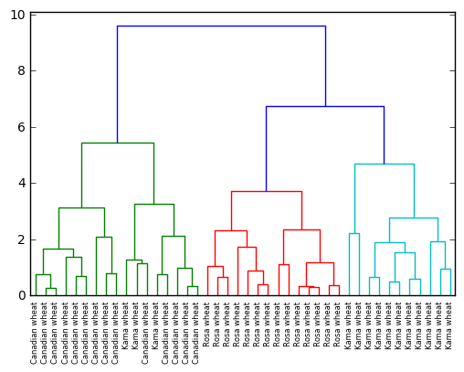

method='single'
# Calculate the linkage: mergings
mergings = linkage(sample, method='single')

# Plot the dendrogram, using varieties as labels
dendrogram(mergings,
labels=variety,
leaf_rotation=90,
leaf_font_size=6,)

plt.show()
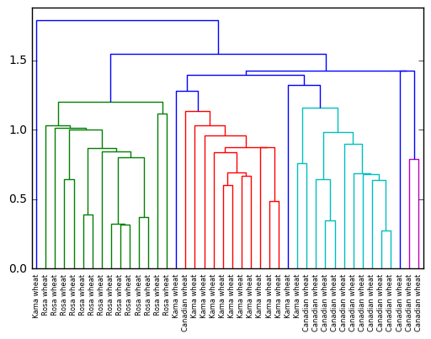

nomalize
SciPy hierarchical clustering doesn't fit into a sklearn pipeline, so you'll need to use the normalize() function from sklearn.preprocessing instead of Normalizer.

y-axis represents the distance between clusters
# Import normalize
from sklearn.preprocessing import normalize

# Normalize the movements: normalized_movements
normalized_sample = normalize(sample)

# Calculate the linkage: mergings
mergings = linkage(normalized_sample, method='complete')

# Plot the dendrogram
dendrogram(
mergings,
labels=variety,
leaf_rotation=90.,
leaf_font_size=6
)
plt.show()
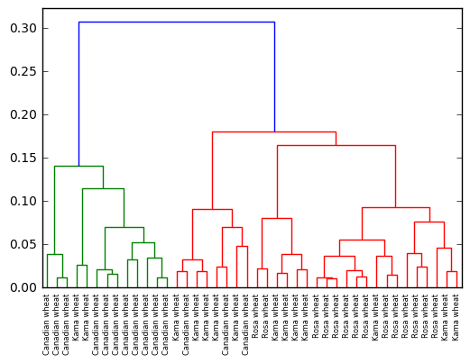

Cluster labels in hierarchical clustering
● Not only a visualisation tool!
● Cluster labels at any intermediate stage can be recovered
● For use in e.g. cross-tabulations

Intermediate clusterings & height on dendrogram
- Dendrograms show cluster distances
  - Height on dendrogram = distance between merging clusters

Intermediate clusterings & height on dendrogram
● Height on dendrogram specifies max. distance between merging clusters
● Don't merge clusters further apart than this

Distance between clusters
● Defined by a "linkage method"
● Specified via method parameter, e.g. linkage(samples, method="complete")
● In "complete" linkage: distance between clusters is max. distance between their samples
● Different linkage method, different hierarchical clustering!

Extracting cluster labels
● Use the fcluster method
● Returns a NumPy array of cluster labels
- In the previous exercise, you saw that the intermediate clustering of the grain samples at height 6 has 3 clusters.
  - Now, use the fcluster() function to extract the cluster labels for this intermediate clustering,
    - and compare the labels with the grain varieties using a cross-tabulation.
# Perform the necessary imports
import pandas as pd
from scipy.cluster.hierarchy import fcluster

# Use fcluster to extract labels: labels
labels = fcluster(mergings, 6, criterion='distance')

# Create a DataFrame with labels and varieties as columns: df
df = pd.DataFrame({'labels': labels, 'varieties': variety})

# Create crosstab: ct
ct = pd.crosstab(df['labels'], df['varieties'])

# Display ct
print(ct)
varieties Canadian wheat Kama wheat Rosa wheat
labels
1 14 3 0
2 0 0 14
3 0 11 0
labels
array([3, 3, 3, 3, 3, 1, 3, 3, 1, 3, 3, 3, 1, 3, 2, 2, 2, 2, 2, 2, 2, 2, 2,
2, 2, 2, 2, 2, 1, 1, 1, 1, 1, 1, 1, 1, 1, 1, 1, 1, 1, 1], dtype=int32)

t-SNE for 2-dimensional maps

“t-distributed stochastic neighbor embedding”

t-SNE for 2-dimensional maps
● t-SNE = “t-distributed stochastic neighbor embedding”
● Maps samples to 2D space (or 3D)
● Map approximately preserves nearness of samples
● Great for inspecting datasets

test on iris dataset
t-SNE on the iris dataset ● Iris dataset has 4 measurements, so samples are 4-dimensional
● t-SNE maps samples to 2D space
● t-SNE didn't know that there were different species
● ... yet kept the species mostly separate

t-SNE in sklearn

apply t-SNE on wheat dataset
from sklearn.manifold import TSNE

# Create a TSNE instance: model
model = TSNE(learning_rate=200)

print sample.shape
# Apply fit_transform to samples: tsne_features
tsne_features = model.fit_transform(sample)
print tsne_features.shape
(42, 7)
(42, 2)

map string names to int index

or use pd.factorize
print variety
['Kama wheat', 'Kama wheat', 'Kama wheat', 'Kama wheat', 'Kama wheat', 'Kama wheat', 'Kama wheat', 'Kama wheat', 'Kama wheat', 'Kama wheat', 'Kama wheat', 'Kama wheat', 'Kama wheat', 'Kama wheat', 'Rosa wheat', 'Rosa wheat', 'Rosa wheat', 'Rosa wheat', 'Rosa wheat', 'Rosa wheat', 'Rosa wheat', 'Rosa wheat', 'Rosa wheat', 'Rosa wheat', 'Rosa wheat', 'Rosa wheat', 'Rosa wheat', 'Rosa wheat', 'Canadian wheat', 'Canadian wheat', 'Canadian wheat', 'Canadian wheat', 'Canadian wheat', 'Canadian wheat', 'Canadian wheat', 'Canadian wheat', 'Canadian wheat', 'Canadian wheat', 'Canadian wheat', 'Canadian wheat', 'Canadian wheat', 'Canadian wheat']
import pandas as pd
pd.factorize(variety)
(array([0, 0, 0, 0, 0, 0, 0, 0, 0, 0, 0, 0, 0, 0, 1, 1, 1, 1, 1, 1, 1, 1, 1,
1, 1, 1, 1, 1, 2, 2, 2, 2, 2, 2, 2, 2, 2, 2, 2, 2, 2, 2]),
array(['Kama wheat', 'Rosa wheat', 'Canadian wheat'], dtype=object))
print map(lambda x:{'Kama wheat':'r', 'Rosa wheat':'g', 'Canadian wheat':'b'}[x], variety)
['r', 'r', 'r', 'r', 'r', 'r', 'r', 'r', 'r', 'r', 'r', 'r', 'r', 'r', 'g', 'g', 'g', 'g', 'g', 'g', 'g', 'g', 'g', 'g', 'g', 'g', 'g', 'g', 'b', 'b', 'b', 'b', 'b', 'b', 'b', 'b', 'b', 'b', 'b', 'b', 'b', 'b']
# Scatter plot, coloring by variety_numbers
plt.scatter(tsne_features[:,0], tsne_features[:,1], alpha = .7,
c=map(lambda x:{'Kama wheat':'r', 'Rosa wheat':'g', 'Canadian wheat':'b'}[x], variety))

# Annotate the points
for x, y, name in zip(tsne_features[:,0], tsne_features[:,1], variety):
plt.annotate(name, (x, y), fontsize=5, alpha=0.75)

plt.show()
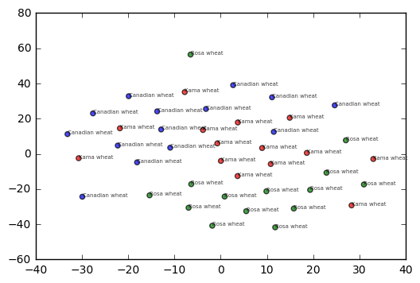

compare with PCA
from sklearn.decomposition import PCA
pca = PCA(2)
sampel_pca = pca.fit_transform(sample)
print sampel_pca.shape
(42, 2)
# Scatter plot, coloring by variety_numbers
plt.scatter(sampel_pca[:,0], sampel_pca[:,1], alpha = .7,
c=map(lambda x:{'Kama wheat':'r', 'Rosa wheat':'g', 'Canadian wheat':'b'}[x], variety))
plt.show()
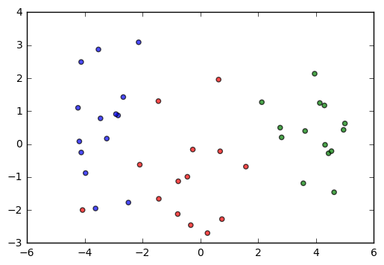

apply t-SNE on iris dataset
from sklearn import datasets
iris = datasets.load_iris()
iri = iris.data
print iri.shape
(150, 4)
from sklearn.manifold import TSNE

# Create a TSNE instance: model
model = TSNE(learning_rate=200)

print iri.shape
# Apply fit_transform to samples: tsne_features
tsne_iri = model.fit_transform(iri)
print tsne_iri.shape

# Scatter plot, coloring by variety_numbers
plt.scatter(tsne_iri[:,0], tsne_iri[:,1], alpha = .7,
c=iris.target)
plt.show()
(150, 4)
(150, 2)
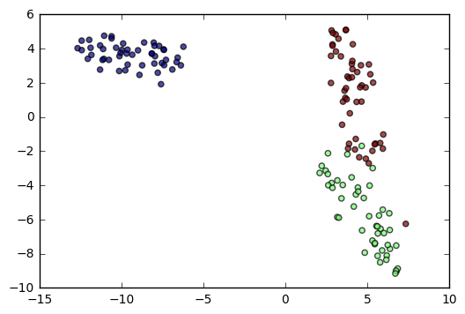

compare with PCA
from sklearn.decomposition import PCA
pca = PCA(2)

print iri.shape
iri_pca = pca.fit_transform(iri)
print iri_pca.shape

# Scatter plot, coloring by variety_numbers
plt.scatter(iri_pca[:,0], iri_pca[:,1], alpha = .7,
c=iris.target)
plt.show()
(150, 4)
(150, 2)
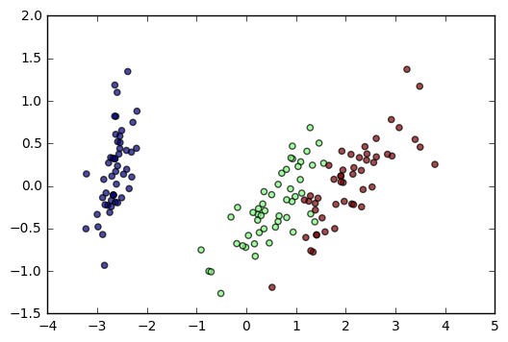

t-SNE has only fit_transform()
● Has a fit_transform() method
● Simultaneously fits the model and transforms the data
● Has no separate fit() or transform() methods
● Can’t extend the map to include new data samples
● Must start over each time!

t-SNE learning rate
● Choose learning rate for the dataset
● Wrong choice: points bunch together
● Try values between 50 and 200

Different every time
● t-SNE features are different every time
● Piedmont wines, 3 runs, 3 different sca!er plots!
● … however: The wine varieties (=colors) have same position relative to one another

>>>>>>>>>>>>>>>>>>>>>>>>>>>>>>>>>>>>>>>>>>>>>>>>>>>>>>>>

Different linkage, different hierarchical clustering!
In the video, you saw a hierarchical clustering of the voting countries at the Eurovision song contest using 'complete' linkage. Now, perform a hierarchical clustering of the voting countries with 'single' linkage, and compare the resulting dendrogram with the one in the video. Different linkage, different hierarchical clustering!
You are given an array samples. Each row corresponds to a voting country, and each column corresponds to a performance that was voted for. The list country_names gives the name of each voting country. This dataset was obtained from Eurovision.

Instructions
100xp
- Import:
  - linkage and dendrogram from scipy.cluster.hierarchy.
  - matplotlib.pyplot as plt.
- Perform hierarchical clustering on samples using the linkage() function with the method='single' keyword argument. Assign the result to mergings.
- Plot a dendrogram of the hierarchical clustering, using the list country_names as the labels. In addition, specify the leaf_rotation=90, and leaf_font_size=6 keyword arguments as you have done earlier.
SOLUTIONS:
# Perform the necessary imports
import matplotlib.pyplot as plt
from scipy.cluster.hierarchy import linkage, dendrogram
import matplotlib.pyplot as plt

# Calculate the linkage: mergings
mergings = linkage(samples, method = 'single')

# Plot the dendrogram
dendrogram(
mergings,
labels=country_names,
leaf_rotation=90,
leaf_font_size=6)
plt.show()

>>>>>>>>>>>>>>>>>>>>>>>>>>>>>>>>>>>>>>>>>>>>>>>>.

Extracting the cluster labels
In the previous exercise, you saw that the intermediate clustering of the grain samples at height 6 has 3 clusters. Now, use the fcluster() function to extract the cluster labels for this intermediate clustering, and compare the labels with the grain varieties using a cross-tabulation.
The hierarchical clustering has already been performed and mergings is the result of the linkage() function. The list varieties gives the variety of each grain sample.

Instructions
100xp
- Import:
  - pandas as pd.
  - fcluster from scipy.cluster.hierarchy.
- Perform a flat hierarchical clustering by using the fcluster() function on mergings. Specify a maximum height of 6 and the keyword argument criterion='distance'.
- Create a DataFrame df with two columns named 'labels' and 'varieties', using labels and varieties, respectively, for the column values. This has been done for you.
- Create a cross-tabulation ct between df['labels'] and df['varieties'] to count the number of times each grain variety coincides with each cluster label.
SOLUTIONS

# Perform the necessary imports
import padas as pd
from scipy.cluster.hierarchy import fcluster

# Use fcluster to extract labels: labels
labels = fcluster(mergings,6, criterion='distance')

# Create a DataFrame with labels and varieties as columns: df
df = pd.DataFrame({'labels': labels, 'varieties': varieties})

# Create crosstab: ct
ct = pd.crosstab(df['labels'], df['varieties'])

# Display ct
print(ct)

>>>>>>>>>>>>>>>>>>>>>>>>>>>>>>>>>>>>>>>>>>>>>>>>....

t-SNE visualization of grain dataset
In the video, you saw t-SNE applied to the iris dataset. In this exercise, you'll apply t-SNE to the grain samples data and inspect the resulting t-SNE features using a scatter plot. You are given an array samples of grain samples and a list variety_numbers giving the variety number of each grain sample.

Instructions
100xp

Instructions
100xp
- Import TSNE from sklearn.manifold.
- Create a TSNE instance called model with learning_rate=200.
- Apply the .fit_transform() method of model to samples. Assign the result to tsne_features.
- Select the column 0 of tsne_features. Assign the result to xs.
- Select the column 1 of tsne_features. Assign the result to ys.
- Make a scatter plot of the t-SNE features xs and ys. To color the points by the grain variety, specify the additional keyword argument c=variety_numbers.
SOLUTION>
# Import TSNE
from sklearn.manifold import TSNE

# Create a TSNE instance: model
model = TSNE(learning_rate=200)

# Apply fit_transform to samples: tsne_features
tsne_features = model.fit_transform(samples)

# Select the 0th feature: xs
xs = tsne_features[:,0]

# Select the 1st feature: ys
ys = tsne_features[:,1]

# Scatter plot, coloring by variety_numbers
plt.scatter(xs, ys, c=variety_numbers)
plt.show()

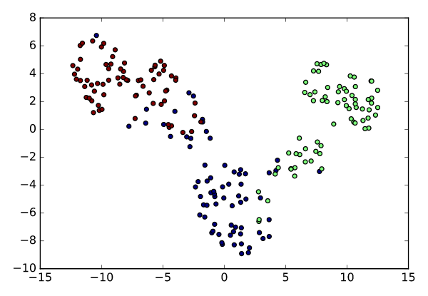
>>>>>>>>>>>>>>>>>>>>>>>>>>>>>>>>>>>>>>>>>>>>>>>>>>>>>>>>>>>....

A t-SNE map of the stock market
t-SNE provides great visualizations when the individual samples can be labeled. In this exercise, you'll apply t-SNE to the company stock price data. A scatter plot of the resulting t-SNE features, labeled by the company names, gives you a map of the stock market! The stock price movements for each company are available as the array normalized_movements (these have already been normalized for you). The list companies gives the name of each company. PyPlot (plt) has been imported for you.

Instructions
100xp

Instructions
100xp
- Import TSNE from sklearn.manifold.
- Create a TSNE instance called model with learning_rate=50.
- Apply the .fit_transform() method of model to normalized_movements. Assign the result to tsne_features.
- Select column 0 and column 1 of tsne_features.
- Make a scatter plot of the t-SNE features xs and ys. Specify the additional keyword argument alpha=0.5.
- Code to label each point with its company name has been written for you using plt.annotate(), so just hit 'Submit Answer' to see the visualization!
SOLUTION:
# Import TSNE
from sklearn.manifold import TSNE

# Create a TSNE instance: model
model = TSNE(learning_rate=50)

# Apply fit_transform to normalized_movements: tsne_features
tsne_features = model.fit_transform(normalized_movements)

# Select the 0th feature: xs
xs = tsne_features[:,0]

# Select the 1th feature: ys
ys = tsne_features[:,1]

# Scatter plot
plt.scatter(xs, ys, alpha=0.5)

# Annotate the points
for x, y, company in zip(xs, ys, companies):
plt.annotate(company, (x, y), fontsize=5, alpha=0.75)
plt.show()
